Procedures and Guidance to support Laboratory Waste & Recycling Policy

Date 24th November 2022

Version 3

How to improve waste segregation in laboratories

Overview

This document sets out guidance and standard operating procedures on each material that may be recycled within laboratories. To accompany such guidance is example signage, operational guidance, and associated responsibilities. Supporting information to guide procurement is also included (e.g. for bags, and for known return schemes which laboratories should consider taking advantage of).

This guidance should be read in conjunction with the Laboratory Waste & Recycling Policy and with the Waste and Resource Strategy and Action plan 2021-24. This document is a live document is updated on an as needed basis. If unsure about any action or guidance listed below, please check with the local lab technical manager for the most up to date information.

All laboratories of containment level (CL) 2 or 1 will produce waste which may or may not be recycled and/or disposed of in general waste, or recycling waste or may be disposed of via an offensive waste stream. Ensure you dispose of the waste correctly, if unsure, check with your lab manager. Improved segregation of waste will have a positive environmental impact, and also reduce cost as recycling and general waste streams can cost up to 4-5 times less to process. To initiate such segregation and recycling within laboratories, there are five crucial steps which must be taken:

- Review risk assessments for the laboratories in consideration. Ensure they are up to date. Such risk assessments will determine what specialised waste methods are required. Ensure relevant H&S officers are made aware and approve of any alterations.

- Consult users within the laboratory about what materials are entering the laboratory which fall outside of risk assessments, and which may be recycled and/or disposed of in general waste. Try to assess what percentage of waste currently disposed of will be appropriate for non-specialised disposal.

- Consult local laboratory management about alterations to current practice. Ensure appropriate bins and bags are obtainable. Note that procedures across KCL will vary depending on location – please consult Section 3 of this document and local management to ensure waste is disposed of correctly.

- Ensure cleaning staff and estates are consulted surrounding any variations in procedure – this is important as it may require variations in disposal methods for cleaning staff. Furthermore, it will permit estates to asses incurred savings and communicate them back to the laboratory.

- Ensure all staff/students are made aware of such variations, relevant signage and induction materials are updated, and impacts and reasoning are communicated. Regular communications are vital to a successful waste segregation system.

- Ensure the Estates and Facilities teams are made aware of alterations to current practice – particularly the Waste to Resource Coordinator and/or Sustainability Manager for Operations.

Recyclable material – Plastics

- Any plastic ware that has been contaminated with biologically or chemically hazardous material must be disposed of via hazardous waste streams. In addition to guidance and signage, lab users are expected to use their judgement when disposing of plastic lab waste,

- All clean, non-composite, plastics that do not contain hazardous waste can be recycled, please ensure this is clearly communicated during induction training as well at waste receptacles. Plastics deemed safe to recycle must be triple washed, i.e. rinsed thoroughly 3 times with tap water (assuming contents are compatible with water) and allowed to dry before being placed in the designated mixed recycling bin. (see annex 1)
- Consider a glass or metal alternative where available and practical– a common debate in laboratories is the benefits of reutilising glass materials vs. disposal of plastics. Use of ‘reusable’ materials will always be more efficient in terms of environmental impact when transport and disposal methods are considered, despite possible autoclaving requirements (often disposed plastics require autoclaving anyway). Please consider reusing glass wares where feasible, as this will also save the laboratory money (plastics are expensive vs. treatment of glass). Ensure technical staff are in agreement on any variations.

- Examples of recyclable plastic include bottles that have harboured only phosphate buffered saline (PBS), molecular grade water and Dulbecco’s Modified Eagle Medium (DMEM); containers of reagents such as sodium chloride; empty falcon tubes; and reagent reservoirs. pipette cover strips, rinsed uncontaminated weighing boats etc.

- All bottles and containers must be separated from their lids and be free from hazard labels.

- All ‘sharp’ plastic ware, including pipettes; pipette tips; and syringes should be disposed of in the designated sharps box or biobin and not in the mixed recycling bin and not in clinical waste sacks.

- Sharps desk bins should be disposed of in designated larger 1100 sharps wheelie bins and not with lager bins containing clinical waste bags.

- All laboratory gloves must be placed in the hazardous waste stream.

- Some companies e.g. Starlab, operate designated services for recycling tip boxes and it is the responsibility of the Laboratory or Resource Manager to organise provision of this service, where it is cost effective and better for the environment.

Recyclable material - Cardboard and paper

- Any cardboard or paper that has been contaminated with biologically or chemically hazardous material must be disposed of via hazardous waste streams.

- Avoid bringing cardboard or other packaging materials into the laboratory at all where possible.

- The following items cannot be recycled and should be disposed of via hazardous waste streams: absorbent paper used for laboratory experiments or laboratory bench clean-up; paper used for laboratory bench protection such as a chemical balance or experiment, clean-up of spilled materials, or any other use that may have exposed the paper to potential contamination.

- Examples of recyclable items include: cardboard boxes used during delivery of laboratory reagents and consumables; empty glove boxes and; any supplementary material on paper that accompanies the delivery of items.

- Recyclable card and paper must be placed in the designated mixed recycling bin.

- Any small cardboard boxes that are safe to recycle must be collapsed and folded before being placed in the mixed recycling bin. Any large cardboard boxes that are safe to recycle must be collapsed, folded and placed in the designated area for disposal (in outside corridor).

- Note that some companies will accept the return of packaging (e.g. NEB) – this must be organised by local laboratory management but is encouraged.

Recyclable material - Aluminium

- Any aluminium that has been contaminated with biologically or chemically hazardous material must be disposed of via hazardous waste streams.

- Aluminium items that are safe to recycle must be placed in the designated mixed recycling bin. Examples include washed aluminium containers used for delivery of laboratory reagents and foil used to prevent light ingress but has not been in contact with chemical reagent or biological materials.

Recyclable material - Glass and glassware

- Any glass or glassware that has been contaminated with biologically or chemically hazardous material must be disposed of via the designated sharps bins.

- Glass or glassware should never be placed in the mixed recycling bin.

- Companies such as Thermo Fisher operate designated services for recycling 2.5L Winchester bottles and it is down to the designated Laboratory or Resource Manager to organise provision of this service.

- Any residue alcohols in these bottles must first be left to evaporate inside a fume hood and then removed from the laboratory for recycling. Please deface any labels.

General Waste

- Any non-recyclable material that has been contaminated by biologically or chemically hazardous substances must enter the hazardous waste stream.

- Any non-hazardous and non-recyclable material should be disposed of via the designated general waste bin.

- Examples of items that should be disposed of via general waste include: packaging; plastics with the resin codes which are not recyclable, and polystyrene.

- Avoid bringing packaging materials into the laboratory at all where possible.

- Gelpacks cannot be recycled, so must be disposed of in general waste. However, Lab Managers are encouraged to offer them to staff to reuse in various ways (e.g.cooling packs)

Clinical and Hazardous Waste

- Classification of such materials is determined through local risk assessments and arrangements. Any chemicals or substances utilised within the laboratory must have typically had an annual but no less than tri-ennial risk assessment conducted, and appropriate practices in place to ensure safe disposal.

- Refer to Safety Procedure SPR-040 “Biological Safety responsibilities, management and arrangements” for specifics of biological waste treatments and disposal.

Offensive Waste

- Where reasonably justified, an offensive waste stream should be integrated into laboratories to capture non-hazardous and non-infectious waste in line with both the List of Waste Regulations (2005) – use of appropriate EWC code – and the Hazardous Waste Regulations (2005) – requirement to not mix hazardous and non-hazardous wastes without an Environmental Permit.

- Guidance in the Health Technical Memorandum 07-01: Safe management of healthcare waste states that waste that has been treated e.g. autoclaved on site from research and laboratory facilities is no longer considered infectious or hazardous and so can treated as offensive waste.

- For the purpose of classification, waste that has been treated on site should be considered as offensive rather than infectious waste so long as the waste does not possess other chemical properties from the presence of residues.

- Examples of treated by autoclave laboratory waste include:

- Cell culture waste
- Biologically Contaminated PPE
- Laboratory consumables

- For best practice and procedures for safe decontamination using an autoclave please refer to SPR040-101-HSS Biological Safety Procedure.

- Untreated waste that is not considered hazardous or infectious can also be disposed of via the offensive waste stream.

- Examples of untreated laboratory waste include:

    - Screened samples from healthy individuals
    - Uncontaminated PPE
    - Animal bedding

- Prior to any changes a risk assessment of the properties of the waste should be carried out by the laboratory technical team to ensure it does not retain any hazardous properties and training should be carried out with all staff who may segregate or handle this different waste stream.

- Offensive waste should be disposed of into yellow and black striped waste sacks, stored separately from other types of waste and placed in black lidded 770L waste carts.

Signage and communication

- Information about what items should go into hazardous, mixed recycling and general waste streams should be included as a key part of laboratory inductions and training with signage and posters hung in laboratories next to associated bins.

- For existing laboratory users, the introduction of mixed recycling and general waste streams should be accompanied by regular communications including: departmental/divisional emails; discussions during building user group (BUG) meetings, Sustainability Champions/ LEAF meetings and with the waste coordinator/sustainability manager for operations; requests for Principal Investigators to reiterate changes to waste processes during laboratory group meetings.

- The laboratory technical team must be readily available to answer questions from laboratory users during the initial roll out of mixed recycling and general waste streams.

- Laboratory and Resource Managers should consider the below simplified posters for mixed recycling and general waste in the laboratory. Note the initial poster excludes cytotoxic/offensive waste streams.

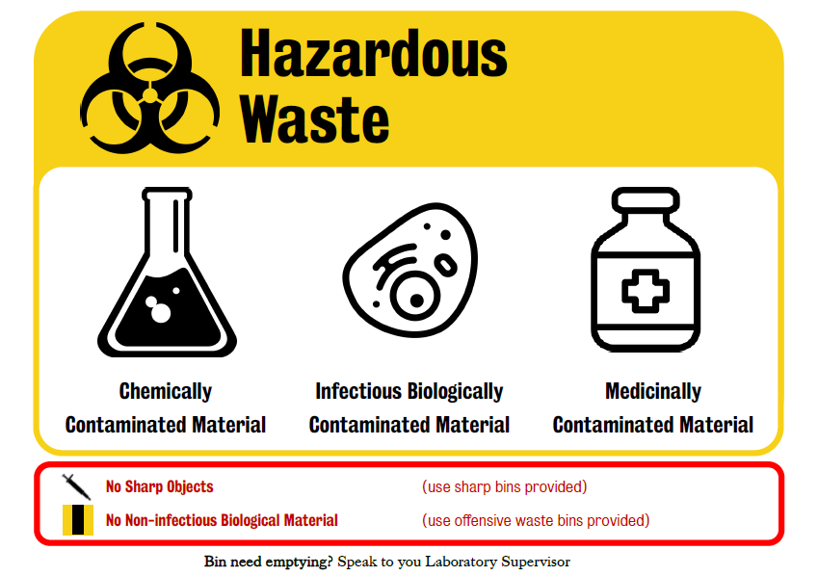
Figure 1 Example Hazardous Waste Signs
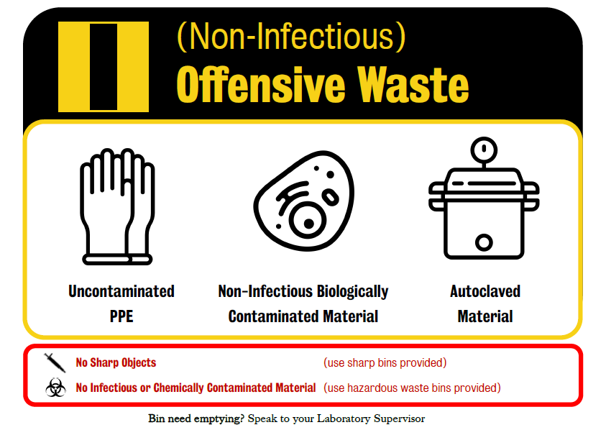
Figure 2 Offensive Waste Sign Example

Operational process

- Materials for recycling and general waste must be collected in designated bins clearly marked “mixed recycling” and “general waste”.(see annex 2)

- The access to these bins must be positioned completely separate from hazardous waste bins in the laboratory, so as to minimise the risk of contamination of recyclable and general waste material with hazardous waste

- Communications indicating acceptable contents must be positioned in the closest possible proximity to the designated bins.

- The correct bags for each waste stream should be used as per your local arrangements with the facilities operator i.e. Bouygues, King’s College London Estates & Facilities GSTT or KCH.

- The Laboratory or Resource Manager must engage with Campus Operations teams to develop a safe and efficient process for removing full bags of mixed recycling and general waste from the laboratory.

- The Laboratory or Resource Manager must engage with Campus Operations teams to ensure adequate provision of bins.

- The laboratory technical team should remove full bags of mixed recycling and general waste from the laboratory and take these items to the designated area as per local arrangements.

Guidance on provision and location of waste receptacles and bags

- Within GSTT operated spaces: Lab users purchase the yellow clinical waste bags through KCEP, though note some departments also source bags from the stores in New Hunts House. Clinical, hazardous, and biological waste bags must be tracked via red GSTT coded tags which are purchased by KCL Estates, direct from the GSTT Waste team. Local laboratory management should be consulted upon any variations.

- Bins for clinical waste must be purchased locally by departments. For domestic waste, recycling, or any queries on procedures, please contact the KCL’s Trust Liaison team: Jennifer Edmondson, jennifer.edmondson@kcl.ac.uk (07468700463).

- Within Bouygues operated spaces (NHH, FWB, WBW):
For clinical waste at FWB/WBW/NHH, contact your local laboratory manager linda.inuabasi@kcl.ac.uk (02078486163).

Technical Managers are listed below.

- Angela Casey angela.casey@kcl.ac.uk is Technical Services Manager • Education, Comms & Society School Office and is responsible for WBW labs (LG/5, 6, 7 8 and 9)
- Paul Rombaut paul.rombaut@bouygues-es.co.uk is responsible for labs in FWB.
- Adrian Shepard adrian.Sheppard@bouygues-es.co.uk is responsible for bulky waste including WEEE in FWB and WBW offices and labs (though there may be costs associated which fall to the department).
- Steve Williams steve.williams@bouygues-es.co.uk. is responsible for waste including bulky waste and WEEE in NHH offices and labs.
- Oliver Austin oliver.austen@kcl.ac.uk Education Technical Manager • Education Operating Services Labs (NHH Ground Floor)
- Celine Trouillet celine.trouillet@kcl.ac.uk, School Technical Manager • Immunology & Microbial Science School Office 1st floor of NHH.
- Risi Mori, risa.mori@kcl.ac.uk is the Senior Technician • Randall Cell & Molecular Biophysics in NHH floors 2 and 3.
- Deborah Coles, deborah.coles@kcl.ac.uk is the Resource Manager • Developmental Neurobiology NHH floor 4.
- Sean Barry, sean.1.barry@kcl.ac.uk. and John Darker John.Darker@kcl.ac.uk, Operations Assistant • Faculty Technical Services Operations Officers, Faculty of Life Sciences & Medicine, both are responsible for FWB and Waterloo.
- For domestic and recycling waste, please contact the helpdesk on x3800 or contact Reannah Yusuff reannah.yusuff@kcl.ac.uk or Rys Bozenza Bozena.rys@bouygues-es.co.uk

- Within KCL operated spaces: E&F Ops is responsible for all general waste and recycling – provision and emptying of bins as well as paying for the waste removal contract. Campus Ops pays for the clinical waste disposal costs (currently Bywater’s (subcontracted to Stericycle)) and the contract is managed by E&F Sustainability team with support from the campus teams. This applies to all directly managed buildings, PFI buildings, but not embedded space where all clinical waste is managed by GSTT/Essentia. Alternatively speak to the central stores at your site.

- For general and recycling waste follow the appropriate local procedures with the local facilities operator.

- E&F do not however, manage the provision of clinical waste bins within labs and nor do we remove the waste to the external clinical waste bins. This is done by the faculty, typically by the lab managers, and is policed by the Faculty H&S Managers. Alternatively speak to the central stores at your site.

- Placement and location of bins: Each laboratory will take into account the requirement of current and possible future waste streams with consideration to space. General waste and recycling should be located separately from clinical, hazardous, and biological waste streams where space permits. All bins should be clearly labelled.

Known/relevant take-back schemes and opportunities available
Currently there are a variety of schemes available to laboratories surrounding good practice and waste, some of which can save time, money, and reduce negative impacts on the environment. The following list is by no means exhaustive. Implementation of some of such schemes may require consultation with local estates and facilities as they may require storage space or variations in disposal. Also note that some of them may be already in practice within your building/area, and you may be able to enter existing schemes. Consult company websites and sales representatives for further details, and in absence of such schemes push them to start!
- Starlab tip box recycling scheme (as well as other companies)
  - Tip boxes from many suppliers, notably starlab, may be gathered and disposed of separately. Tip boxes are not actually reused typically by the company, but will be ground and utilised elsewhere. Typically companies will not dispose of other companies tip boxes, and such boxes should not be contaminated with biological or hazardous substances. Use refillable tip boxes where feasible.

- NEB (New England Biochemical) Polystyrene box return
  - All boxes polystyrene boxes possessing a green line on the address of the package may be returned to NEB. Simply remove the address, and the green line below will possess a return-to-sender sticker which may be applied to the box for return. This helps avoid build-up of polystyrene, and boxes will actually be reused by the company.

- VWR/Fisher/Sigma Winchester Return
  - All companies will take back glass Winchesters for reuse. Typically this requires a high enough volume of bottle consumption, but is ideal as the they will be reused. Consult relevant companies for details.

- Warp-it/Richmond Scientific/and UnigreenScheme Repair services for Equipment.
  - Equipment which is no longer needed but has use may be shared within the college via Warp-it. Go to https://www.warp-it.co.uk/kcl for more information on how to register and use this system.
  - For lab equipment which is no longer needed please contact UniGreenScheme (Michael McLeod michael.mcleod@unigreenscheme.co.uk) to arrange a collection.
  - Where applicable some Lab equipment also be sold to some companies such as Richmond Scientific – please check with Lab manager/principal investigator.

Annex 1.Non Hazardous lab recycling poster.

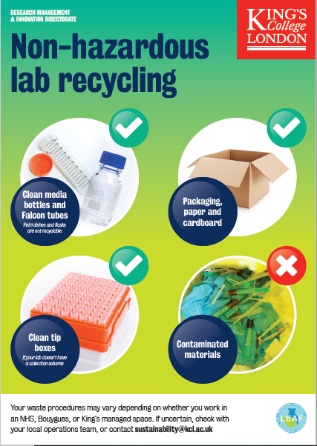

Annex 2.

